## Merchant Name *2X Marketing* Implementation POC: Royce *(IM to fill)* CX POC: *[IMP to Add]*

### 

### 

| Notes Sections   *(AE to fill if they have, Implementation to be completion DRI on handoff)*   * Info on how merchant bills * SF as CRM - finance starts when opp marked closed won, manually pulling SOW * Use third party solution integrated within Netsuite, continuum billing - a lamer version of suite billing * Then build a subscription schedule applicable to that customer based off of the resources that we have on the engagement. * Then set it up to bill for the full period for the first applicable month that it's scheduled to kick off on with * Most contract language is evergreen but schedule a year and a half out * contracts get amended pretty frequently - adding additional services * use an excel workbook as source of truth, a separate tab for each client within that. * forecast out a revenue by month by SOW that we have for client across the rows. * we look to kick off that engagement within two weeks of the signature date, with a pro rated first month. * billing schedule set up so 10 days before the bill date, it will generate the invoice within Netsuite that gives us a period to review. * then do revenue reconciliation between workbook and Netsuite invoices or transactions going through. * then see that Netsuite had the full amount that our workbook had a pro rated amount based off forecast * That triggers to get the actual and update the workbook. * I would update the invoice manually by editing that first invoice that's already been generated. And then at that point, have a bulk set of invoices * Once I've gone through every client's reconciliation, we would then bulk transmit out those invoices. * At the end of the month for our variable input for some ad hoc work or project based work, we get the feedback from the delivery team. And then with that manually update those invoices, whether it's adding a line item to a recurring lead generated invoice, or just creating an additional manual invoice * 1) What is the merchant temperament? * Very friendly and excited about Tabs vision. Will be a great product feedback partner as we launch new features, especially AR agents   3) What are the Tabs features that the key POC cares about?  Billing and revenue schedule automation from contract (Pandadoc) that then automatically integrates with Netsuite and SF. They also have a lot of products and services amendments and adjustments so need Tabs to automatically update invoice start dates based on a trigger from SF or their CS team, pro-rate invoices for mid month and easily add/remove products based on amendments or price adjustments |
| --- |

### Billing model *(Entire Section: Implementation to fill section)*

* Are there unique things about the customer creation process for this merchant?
* Information on how merchant bills
* How contract is broken up
* One off things to know about the merchant

### Contract Processing Steps *(Entire Section: Implementation/Success to fill Post-Go Live)*

* **General**
* These instructions apply to both Intelligent Demand and 2X.
  + *However, there are also Intelligent Demand specific instructions* at the bottom. Please incorporate if processing for Intelligent Demand.
* If the contract is an amendment:
  + Ensure original BTs are adjusted or supplemented according to the amendment's changes.
  + If there are net new BTs from the amendment AND it adjusts the original contract
    - First - adjust original BTs to end before the amendment date
    - Second - add new BTs as per the amendment under the amendment contract.
    - Add proration BTs for first and last month (if needed) under the amendment contract (explanation of proration requirements below)
  + Example of amendment that modifies old contract + adds new BTs:
    - [Original](https://garage.tabsplatform.com/prod/contracts/2a89e78d-ce78-46f5-84d3-f93ea0d4da26/preview)
    - [Amendment](https://garage.tabsplatform.com/prod/contracts/0248a504-51de-4a38-80d8-97505dd68a3c/preview) (shortened old BTs 3 months and created a new monthly BT
* Customer-Specific Instructions
  + Be careful with Broadcom contracts:
    - They may look like duplicates but are probably not
* **Categories**
* For 2X, ***we will be combining different categories of line items into a single BT***
  + The 5 categories will be
    - MRR (Monthly Recurring Revenue)
    - Project
    - Ad-hoc
    - Program Spend
    - Reimbursement Travel
  + The most common will be MRR and Project
    - For MRR
      * Examples: Monthly Labor Fees (both general and specific to employee line items.
      * The below 2 screenshots would each be combined into 1 BT
      * 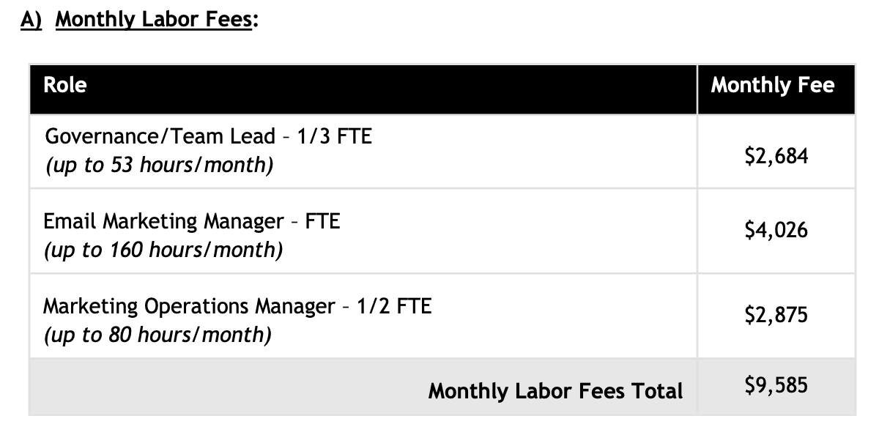
        + [Example](https://garage.tabsplatform.com/prod/contracts/37a693aa-7aa4-4668-b857-57457f046a6f/terms/key)
        + BT will be “Monthly Labor Fees” for $9,585 monthly

Follow the below proration instructions if needed

* + - * 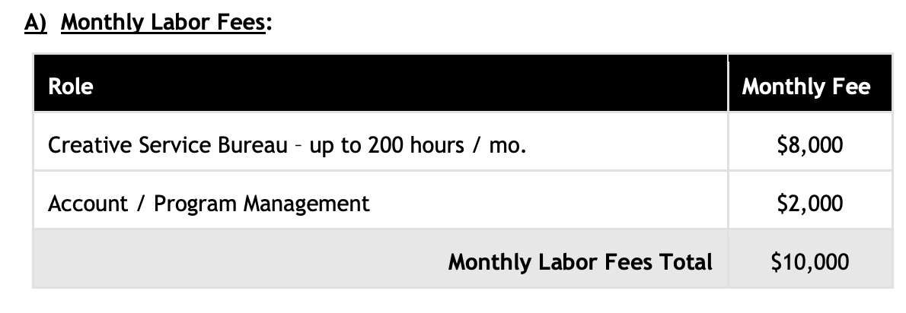
        + [Example](https://garage.tabsplatform.com/prod/contracts/d3ec0d97-054e-4891-8312-68136b98be01/terms/key)
        + BT will be “Monthly Labor Fees” for $10k monthly

Follow the below proration instructions if needed

* + - For Project Fees
      * Defined as anything that is one-time revenue for a project
        + Examples:

A contract refers has a fixed fee on the front end of a contract to cover transition and onboarding tasks.

Contract is for less than 6 months, has a total fixed fee, or a monthly fixed fee

* + - For Ad-hoc work
      * Defined as hourly work that is one-time revenue
        + Example:

An hourly rate is stated and the contract notes that we will bill based on actuals (not common but this is present in some contracts)

* + - For Program Spend
      * Example:
        + The contract references 2x to cover third-party spend incurred on behalf of the customer and charged back to them with no mark-up.
        + Common customers are LinkedIn, Google Ads, Bombora, etc.
    - For Reimbursable Travel
      * Example:
        + Expenses to be reimbursed by the client. This item would likely only be used in the manual creation of an invoice through Tabs.
        + Unlikely to see this
  + *NOTE: you will only have 1 type of each category in a contract*
    - Ignore the prorated BTs. You will never have 2 MRR type BTs. You will never have 2 Project BTs. They should be combined into 1.
    - However, you could have 1 MRR BT and 1 project BT
* **Item Name**
  + Should be a variation of the name of the category - can use best judgment + take what the contract says
    - For Monthly Recurring Revenue
      * “Monthly Labor Fees”
      * “Monthly Recurring Fees”
    - Project Fees
    - Ad-hoc Fees
    - Program Spend
    - Reimbursement Travel
  + Can call discounts “Discount”
* **Item Description:**
  + First take the header of the document at the top (will be an SOW description - is often in Red text)
    - “Statement of Work #1: Marketing Operations Support”
    - If it’s not on 2X paper, use best judgment and put whatever contract description will be a unique identifier
    - *Do not use all caps* - change the capitalization as needed
  + Then add a “-” + either…
    - “Monthly Recurring Charges”
    - or “Transition Project” (+ description of portion being charged if it states for example “50% paid on kickoff”)
    - If the BT fits neither category, just include the category
      * I.e. “- Ad-hoc”, “- Program Spend”, etc.
  + Example: “2X Statement of Work #2: Creative Service Bureau - Monthly Recurring Charges”
* **Integration Items** (*2x instruction only)* - (**you can only choose one of the below) **if the below integration items don’t exist, please leave it blank
  + MRR - Fixed Resources
    - (choose this option if you combined 2 types of MRR)
    - there are fixed quantities of specific resources, at specific individual rates
    - Full time employee charges (“FTE”)
  + MS - MRR Shared Services
    - For is there are a fixed numbers of hours allocated across a variety of different roles
  + OTP - Transition Project
    - (choose this option if you combined 2 types of project fees)
    - fixed fee on the front end of a contract to cover transition and onboarding tasks
  + OTP - Other Project
    - <6 month contract, total fixed fee or a monthly fixed fee
    - doesn’t reference it being an onboarding or transition project
  + ADH - Ad-hoc work (definition above)
  + Program Spend (definition above)
  + Reimbursable Travel (definition above)
* **Monthly fee proration instructions**
  + General
    - [Loom video explanation](https://www.loom.com/share/4c8719c1e8de4fc3bdb959308ccbd9a9)
    - 2x prorates their monthly fees. This means for any billing item that *doesn’t start on the first of the month will need 3 BTs in garage*
    - Make sure to follow the appropriate billing start date instructions based on the below
    - IF a BT is billed less than 4 days away from the start of the month, you can just start it on the 1st of the month that it is *closest to* and ignore prorating.
      * Example
        + -> if one BT starts Dec 28, 2024 AND a second BT starts on on Jan 4, 2025
        + -> we can start BOTH of these on Jan 1, 2025 because that is the closest first of the month and both are within 4 days
    - Total months of service:
      * For each BT, it should match the # of periods
        + For the 2 prorated BTs, it should be 1
    - If a contract is open-ended
      * This means that it doesn’t have a defined end date
        + This could be a contract that is on auto-renewal
        + Or that says continues “Until Terminated”
      * If the contract is like this, there is no need to create a 3rd prorated BT in the below instructions
        + If there is a defined end date, we need to create it
      * If a contract is open-ended, we need to make sure that the long BT gets extended through 12/31/2026 at least
  + Example of when we need to create prorated BTs:
    - Contract has “$1K monthly fee that starts billing Jan 15, 2025”
    - 3 BTs need to be created
      * Only if there is a defined end date in the contract, otherwise ignore this step
    - First BT (the normal fee):
      * Service start date and billing start date: Feb 1, 2025 (first of the next month)
      * 23 for # of periods, occurring monthly
        + Because the contract is open-ended we have to make sure this extends through 12/31/2026. Used 23 months here because 24 months is our default length
      * $1K price
    - Second BT (First Month Prorated):
      * Item name: Line item name + “(First Month Prorated)” at the end
      * Starts Jan 15, 2025,
      * # of periods = 1
      * Frequency: the # of days to get to the end of the month (calculated end date should say Jan 31, 2025 in this case)
      * Billing Timing: *Last of Period*
      * **$548.42 price** 
        + (1k / 31 days * (31-15); 31 days in Jan, 17 days left in the month)
        + Will need to calculate based on the number of days left in the month

Pro tip: you can type into google “prorated 1000 monthly service starting jan 15, 2025” and it will give you the calculation

* + - * + **\*\*\*IF\*\*\*** you cannot determine when the BT starts

Example: “SOW starts within 2 weeks of kickoff”

The BT will be **$0**

This is so the merchant can fill it out when the BT starts

* + - Third BT (Last Month Prorated):
      * Item name: Line item name + “(Last Month Prorated)” at the end
      * Starts Jan 1, 2027
        + This is be the last month of the term. You can find this by taking the **first month after** the calculated *billing* end date of the normal fee BT

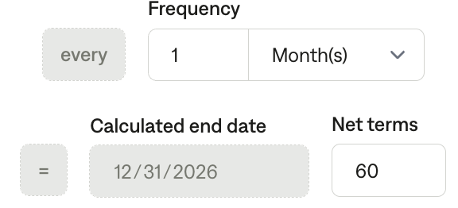

* + - * Frequency: number of days remaining
        + Take the # of days from the first prorated month and subtract it by the number of days in the month (31 for Jan)
      * Billing Timing: *First of Period*
      * # of periods = 1
      * **$451.58 price ($1k minus $548.42)**
        + The start date covers the extra 15 days from Jan 1, 2027 to Jan 15, 2027 that need to be paid for
  + The reason we prorate is so that the merchant can fill in the correct prorated amount in the future when they know what the official invoice date will be
  + IF we know the exact start date (meaning it does not start *within X weeks*) - we can do the proration calculation
    - [Example](https://garage.tabsplatform.com/prod/contracts/0248a504-51de-4a38-80d8-97505dd68a3c/preview)
    - If you are unsure if you should be prorating, please do so.
    - If you can figure out when the BT starts, you should be prorating.
      * For example, “Starts 2 weeks after execution” - should prorate since we can calculate the start date
  + *Prorating is ONLY for recurring monthly fees* -> one-time fees will not be prorated
* **Project with defined billing schedule**
  + For example: Project fee with a defined billing schedule that looks like: 50% at contract start date and 50% at project completion:
    - 8 weeks is the assumption of project length, so the project completion billing date is the contract start date + 8 weeks
      * So the billing start date for project completion is contract start date + 8 weeks
    - For service period:
      * First 50% should be recognized the first 4 weeks
        + Service start date is contract start date
        + Months of service is 1 (4 weeks = 1 month)
      * Second 50% should be recognized in second 4 weeks
        + Service period start date should be contract start date + 4 weeks
        + Months of service is 1
* **Billing Start Date:**
  + First check the “Invoicing Terms” or “Timeline” section
    - Very often, billing terms will “start within [ ] weeks for signature date”
      * Use the largest time unit listed - so if 4-6 weeks, use 6 weeks
      * Example
        + Contract signed 12/23/24
        + “Engagement will start within two weeks of SOW #1 signature, and continue until termination or modification.”
        + 12/23/24 + 14 days = 1/6/25 start date
        + Start date should be 1/6/25
  + But if the billing term has its own dates, please use those.

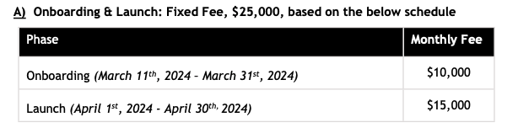

* **Service Start Date:**
  + Same as billing start date
* **Months of Service:**
  + *Default to 24 months as the total contract length if there isn’t a length listed - many of the 2X contracts are open ended*
  + Unless the specific date ranges is given
    - If contract says a service will take 6-8 weeks, months of service would be 2 months
    - For shorter BTs like onboarding, use the time they list and round up.
      * If 2 weeks -> 1 month
      * If 6 weeks -> 2 months
  + If they don’t list a timeframe, use best judgement
* **Frequency**
  + Mostly can determine from invoicing terms section
    - “Onboarding & Launch: Fixed Fee”
    - “Monthly Labor Fees”
  + If a fixed fee for deliverables is listed, use None.
* **Net Terms**
  + Look at Invoicing section
    - Typically "Invoices delivered monthly with 30-day payment terms."
  + If not stated, default to 30.
* **Quantity:** Use 1 for everything
* **Discounts:**
  + - If its own line item, make a separate BT



* + - If part of the specific billing item, use in-line + discount
* **Intelligent Demand Contract Instructions**
* Billing and Service Period Start Dates
  + If it’s in a closed period, make the start date the first day outside of the closed period
* Integration items (there are only 3 possible products for Intelligent Demand)
  + For Agency Fees
    - Integration item: PROGRAM SPEND - Third Party Expenses: Third Party Expenses
  + For Media Spend
    - Integration Item: Program Spend - Media Spend
  + For Reimbursable Travel Fees
    - Integration Item: Passthrough Spend - Travel
* If you see a table of hourly rates:

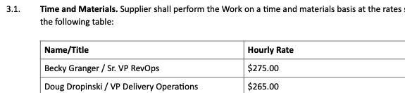

* + **Ignore** and only process the listed “budget” or “quota” amount as a flat price BT

1. Anything to ignore in contracts?
2. Specifics processing things the merchant has requested that may differ by contract (e.g. always back-date invoice date to final day of the month)
3. Default Service Term
   1. If None Listed, Ops Default is 1 Year
4. Default Net Payment Terms
   1. If None, Ops Default is 0
5. Default Billing Frequency
   1. If None Listed, Ops Default is Monthly
6. How do we handle taxes as a line item?
   1. If None Listed, Ops Default is every tax line item becomes a BT

### Events Processing (if necessary) *(Entire Section: Implementation/Success to fill Post-Go Live)*

* Any important information on events billing

Integration Items Processing (if necessary)  
*(Entire Section: Implementation/Success to fill Post-Go Live)*

* What are the instructions for assigning integration items?
* Example: All Statsig integrations items should be labeled as “Sales”
* Example: All “Pinata” integration items should be labeled as “Software Subscription Bundle” unless otherwise noted by Merchant

Post Processing Communications (if necessary)  
*(Entire Section: Implementation/Success to fill Post-Go Live)*

* Does the Ops Team need to notify anyone on the team re: completion of processing batches in Implementation or Active phase?
* Who needs to be notified and when?
  + Example:
    - Who: Customer Success [Azmat Aziz] needs to be notified
    - Where: Messari internal merchant channel
    - When: contracts are processed [Merchant Phase: Active]

### Customer Information *(Entire Section: Implementation/Success to fill Post-Go Live)*

* Any important information on specifics customers of this merchant
  + Special memo’s certain invoices require
  + Invoice changes due to merchant/customer relationship

### Feature Requests *(AE to fill for all requests prior to Imp handoff, Imp to fill prior to go-live/Success to fill to fill Post-Go Live)*

* FR 1
  + What is it
  + Invoice pro-ration
  + Why it's important
  + They have a lot of invoice changes that happen throughout the month and need to programmatically adjust them
  + Urgency
  + By go live

<https://docs.google.com/presentation/d/1mm5jLkteppoiCh4Hz7TJBFFcY2JMG2iKfdxxidzZJco/edit#slide=id.g3142b1e74ee_0_0> arjun has signed off on the attached needs presented to the 2X team here

### Merchant Calls *(AE to fill for all videos prior to Imp involvement, Imp to fill prior to go-live/Success to fill to fill Post-Go Live)*

* Loom recording links by dates
* <https://us-56595.app.gong.io/call?id=4861806357239532146> 4/7 call with the team